**Английский язык, 6 класс**

**Демо-вариант**

***1. Прочитайте текст и определите, о чем он.***

1. Favourite season

2. Where the rain comes from

3. The questions to answer

4. Rain in the bathroom

5. The circle of rain

1. What weather do you like? Do you like summer when it is hot or winter when it is cold and snowy? Maybe you like spring with its flowers or autumn with its yellow leaves. All seasons are great but my favourite is autumn. I like the colour of trees and I also like walking in rainy weather. I like rain but I don't know where it comes from. Here is what I could find out.
2. As far as I know, rain always comes from clouds. But where do clouds come from? How does all the water get into the sky?
3. Think about your bathroom. There is hot water in your bath. Steam goes up from the hot water. The steam makes small clouds in the bathroom. These warm clouds meet the cold walls and windows, and then we see small drops of water on the walls and windows.
4. The world is like your bathroom. The water in the oceans is warm when the sun shines on it. The wind carries the clouds for hundreds of kilometres. Then the clouds meet cold air in the sky, and we see drops of water. The drops of water are rain.
5. The rain falls and runs into rivers. Rivers run into the oceans. And the water from oceans makes clouds and more rain. So water is always moving from oceans to clouds to rain to rivers to oceans. So the rain on your head was on other heads before! The water in your garden was in other gardens in other countries.

**Запишите выбранные цифры под соответствующими буквами.**

|  |  |  |  |  |  |
| --- | --- | --- | --- | --- | --- |
| Ответ: | A | B | C | D | E |
|  |  |  |  |  |

***2. Прочитайте текст и вставьте вместо каждого пропуска нужную грамматическую форму, выбрав её из списка.***

Hi! 1)_____ name's Linda. I am 15. I've got fair hair and blue eyes. I like sport. I 2)_____play football very well. But my favourite sport is tennis. I 3)_____ a dog, Dan. We 4)____ at the park now. Dan is running and jumping. I'm hungry. I have got two 5)______. One is for me, and the other is for Dan.

|  |  |  |  |  |
| --- | --- | --- | --- | --- |
|  | **A** | **B** | **C** | **D** |
| **1** | My | We | I | She |
| **2** | am | have got | can | is |
| **3** | am | have got | can | be |
| **4** | am | is | are | be |
| **5** | sandwich | sandwichs | sandwiches | sandwichies |

**Запишите выбранные буквы под соответствующими цифрами.**

|  |  |  |  |  |  |
| --- | --- | --- | --- | --- | --- |
| Ответ: | 1 | 2 | 3 | 4 | 5 |
|  |  |  |  |  |

***3. Прочитайте текст и вставьте вместо каждого пропуска подходящее слово, выбрав его из списка. Два слова в списке лишние.***

Dear James,

My name's Kate. I'm A)________.I've got dark hair and brown eyes .I can B)_______, run and swim. My favourite food is C)________.I've got a D)_______, Patrick. He's six. He's got red E)______and green eyes. What can you do? What's your favourite food? Have you got brothers or sisters?

Write soon.

Love,

Kate

1. brother 2. Jump 3. dog 4. nine 5 ears 6. pizza 7. hair

**Запишите выбранные цифры под соответствующими буквами.**

|  |  |  |  |  |  |
| --- | --- | --- | --- | --- | --- |
| Ответ: | A | B | C | D | E |
|  |  |  |  |  |

***4. Выберите фотографию и опишите ее (7–8 предложений). Вопросы помогут вам:***

1. What can you see on the picture?
2. What are the people doing?
3. What do the people look like?
4. Do you like the picture or not?

 Start with: **“I’d like to describe picture № ... .”**

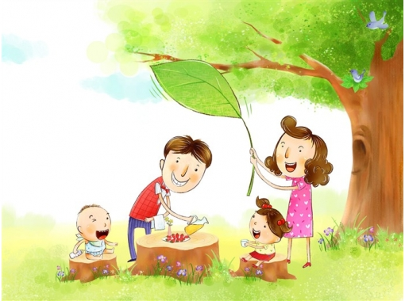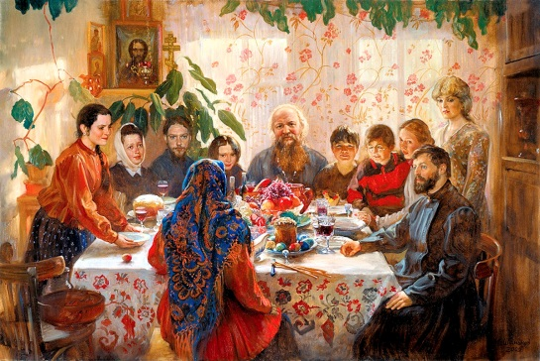

|  |  |
| --- | --- |
| Photo 1 | Photo 2 |