Английский язык, 6 класс

БАНК ЗАДАНИЙ
для подготовки к промежуточной аттестации

1. Прочитайте текст и определите, о чём он.

Текст 1

- There are three rooms, a kitchen and a bathroom .I t’s very comfortable. We have got all modern conveniences, such as central heating, electricity, gas, running water.
- Tanya is my classmate. She is a Russian girl. She is in the fifth form. She is a student of School Number 44. Tanya is young, she is twelve years old. She is a bit taller than me. She looks like her mother. She is pretty. Tanya is a thin girl with large brown eyes. Her hair is fair, long and straight. Her face is oval and her nose is turned-up. She wants to look like all the models. We like to spend a lot of time together.
- Before the 16th century, people in Europe didn't have a lot of the things that we can eat and drink every day. At the end of the 15th century, people from Europe started to travel to other parts of the world. They went to America, Africa and Asia. They brought back a lot of new kinds of food.
- Animals are very important to people. We keep dogs and cats as pets. Some farmers have sheep and cows to produce meat and milk. We ride horses. We watch lions and tigers at the circus. For people who love animals, working as a veterinarian is an ideal job. Veterinarians treat many kinds of animals such as dogs, cats, guinea pigs, cows, pigs and horses.
- All people like this kind of food. You can add meat, sausage, cheese to your taste. They have two thin slices of bread. You can put butter and meat between the two slices. A lot of people in England eat them for their lunch.

Текст 2

- What weather do you like? Do you like summer when it is hot or winter when it is cold and snowy? Maybe you like spring with its flowers or autumn with its yellow leaves. All seasons are great but my favourite is autumn. I like the colour of trees and I also like walking in rainy weather. I like rain but I don't know where it comes from. Here is what I could find out.
- As far as I know, rain always comes from clouds. But where do clouds come from? How does all the water get into the sky?
- Think about your bathroom. There is hot water in your bath. Steam goes up from the hot water. The steam makes small clouds in the bathroom. These warm clouds meet the cold walls and windows, and then we see small drops of water on the walls and windows.
- The world is like your bathroom. The water in the oceans is warm when the sun shines on it. The wind carries the clouds for hundreds of kilometres. Then the clouds meet cold air in the sky, and we see drops of water. The drops of water are rain.
- The rain falls and runs into rivers. Rivers run into the oceans. And the water from oceans makes clouds and more rain. So water is always moving from oceans to clouds to rain to rivers to oceans. So the rain on your head was on other heads before! The water in your garden was in other gardens in other countries.

Текст 3

- Anna is my friend. She has an oval face, grey eyes, straight nose and full lips. She has long curly hair. She is slim and tall.
- I like reading. I go to the library and take interesting books. I like to read short stories about animals. Sometimes I read poems.
- Sam is my parrot. Sam is five years old. Sam has got a big beak, two wings and a beautiful tail. My parrot is very colourful: red, white, blue and yellow.
- In winter we celebrate New Year's Day. We decorate a New Year tree. I like to give presents to my parents and friends.
- My mother and I came to a shop. Mother said, "Lily, you need a new dress and a new blouse for school. Look, this white blouse looks nice! Try it on, please!"

Текст 4

- Wild animals live in the forest or in the zoo. Some animals are dangerous. A fox, a wolf, a bear, a hare, a tiger, an elephant are wild animals.
- For breakfast I like to eat sandwiches and tea or milk. I like to drink apple or orange juice. I also like to eat chicken and potatoes. I like a salad with tomatoes and cucumbers. I also eat fruit and vegetables.
- I haven't got a big family. I have got a mother, a father, a sister, and a grandmother. My mother is young and beautiful. My father is young, too. My sister is four and she doesn't go to school yet.
- I get up at seven o'clock. Then I wash myself, put on my clothes and have breakfast. After breakfast I go to school. I come home at one o'clock. After dinner I do my homework. In the evening I read or watch TV. I go to bed at nine o'clock.
- I have got a lot of friends. They are my classmates. We go to school together in the morning. And we return home together after classes. We like to play. We play different games.

Текст 5

- Hi! My name is Kate. I'm twelve years old. and I'm sailing around the world with my family. My brother Nat and I don't go to school. We have lessons with our mum and dad on the boat.
- Captain Cook came from England. He was a great explorer and travelled to New Zealand and Australia.
- My uncle's house is underground, but it isn't dark. There are four windows. There's a living room and a kitchen, a bathroom and two bedrooms.
- Dolphins are cool. They can jump and they can sing. Some dolphins can even paint! But they see only black and white.
- Chinese New Year is usually in January or February. Every year people have a special street party with people playing drums and wearing special clothes.

Текст 6

- This is a Christian holiday celebrating the birth of Christ. It's mostly celebrated on December 25th. People decorate a special tree, have a holiday feast, eat traditional food and exchange gifts.
- It's celebrated on the fourth Thursday in November in the United States and on the second Monday in October in Canada. It's a day when people have a large meal together to celebrate and be thankful for families, health and food.
- The evening before All Saints' Day. Some people believe that the souls of dead people appear on this day. Children like wearing costumes and going trick or treating in order to get sweets.
- On November 5th, British people light fireworks and have a tradition to burn a "guy" on a fire. The guy's name was Guy Fawkes and he was an English conspirator who played an important role in British history.
- A day observed by the Irish to commemorate the patron saint of Ireland, who helped to spread the Christian religion there. It is celebrated on March 17th. People drink Irish beer and often wear green clothes on this day.

Текст 7

- Los Angeles, California is the most exciting place in the USA. It's got Hollywood, Disneyland, fantastic beaches and the LA Dodgers baseball team.
- I like Justin Timberlake. He's a fantastic singer and dancer. I've got all his albums and I've been to twenty of his concerts too, but I've never met him. That's my dream!
- My dad and I are going to the Himalayas. We are going to fly to Kathmandu first and we'll probably do some shopping there. Then we're going to travel to Lukia.
- I'm Ivan. I live with my mum, my dad, my grandma and my sister. Our house is in a small village. Mum and Dad go to work every day, so Grandma looks after the house.
- Ceviche is one of Peru's national dishes. It is raw fish in citrus juice. People usually use lemons or limes to make ceviche. They put pieces of fish in the lime or lemon juice with sliced onion, garlic and hot peppers.

Текст 8

- My family is big. I have a mother, a father, a sister, a brother and a grandmother. My parents are doctors. They work at the hospital. My brother is a good sportsman. My sister is a little girl.
- I go to school 5 times a week. I like going to school. I like my friends and teachers. I like English. At the English lesson we speak, read and write. I like speaking and reading English very much.
- Kate likes animals. She has a cat, a dog, and fishes. Her cat pussy is old. She is 14. She is grey. She likes fish and meat. She doesn’t play. She always sleeps. Kate’s dog Jim is young. He is 2. He is black. He likes running and jumping. He always plays with Kate.
- I have many friends. They are boys and girls. Their names are Bill, Tom, Sam, Elly and Ann. Tom is a good sportsman. He plays hockey, football and basketball very well. Bill loves reading. He reads books about children and animals. The girls like singing and dancing.
- We like many sports and games. We like playing football, basketball, volley-ball, tennis, ping-pong, and hockey. We like skating and skiing. We run and jump, swim and drive. We like sports very much.

Текст 9

- We are very fond of having picnics. On Sundays our family goes to some nice place in the country. We like to sit in the open air and enjoy nature. It’s a pleasure to have lunch in a forest or near the water. We can also play ball or swim if the weather is fine.
- My best friend and I often go to the discos. We listen to music and dance there. It’s fun! Rock is our favourite type of music. And we enjoy listening to jazz.
- We have two dogs. Their names are Terry and Rex. We love them so much! Every day we take them for a walk in the park. They are so polite and nice when they meet other dogs there. I think they say «Hello!» to them in their dog language.
- All my friends love sport. Our favourite sports are horse riding, football and swimming. Every school and college has its own football team. We often have sport competitions at our school. It‘s great when your team wins!
- The English eat millions of sandwiches every day. They are a typical “snack” meal because they are easy and quick to prepare. You can buy sandwiches if you don’t want to make them yourself. There are thousands of sandwich bars and cafes and even some restaurants that sell them.

Текст 10

- This is a large reptile with a long mouth and sharp teeth. It lives in lakes and rivers. This animal is very dangerous because it eats meat.
- This is a big and powerful animal. It lives in Asia and Africa. It has very thick skin and one or two horns. This animal eats grass and plants.
- This animal is a large wild cat. It has yellow fur with black spots on it. It lives in Africa and southern Asia. It chases other animals for food. It's very fast.
- This large animal lives in the desert. It has one or two raised parts on its back which are called humps. It has short brown fur and long thin legs.
- It's a kind of snake that can make the skin of the neck bigger. It slides along the ground. Its bite is poisonous and can kill.
2. Прочитайте текст и вставьте вместо каждого пропуска нужную грамматическую форму, выбрав её из списка.

Текст 1

Hi John!
Thanks for 1). _____email. I've got some exciting news. We're going to live in Lapland for a year! My dad 2). _________got a job in Saariselkä and we're going to fly there in November. It 3). ________ a lot in November and there aren't 4). _______sunny days. I'm going to get to school by snowmobile – with lights on! It's dark in winter, but it's beautiful. 5). ________ sometimes see the Northern Lights in summer.
Write soon.
Best wishes,
Luke

1 | your | yours | you | you`re
2 | have | do | does | has
3 | is snowing | snows | snowed | snowes
4 | some | a | much | many
5 | person | persons | people | people

Текст 2

Прочитайте текст и вставьте вместо каждого пропуска нужную грамматическую форму, выбрав её из списка.
1). _____all animal sounds in your language? Sometimes sounds can be really different in different languages. What about English? Cats usually say "meow", especially if they want something. If a cat 2). ______ happy and satisfied it "purrs". All dogs 3). _________but they can make such sounds as "woof", "bow-wow" and "yap". A cow 4). _________"moo". Ducks 'quack' but geese "honk". So what sounds 5). _______ these animals make in your language?

1 | Do you know | Are you know | Does you know | Do know you
2. | be | am | is | are
3. | bark | barks | barking | are barking
4. | say | says | saying | are saying
5. | do | does | are doing | doesn`t

Текст 3

What time 1). _________ you get up every day? This girl gets up earlier. Her morning usually starts at five o'clock! 2). _____ name is Louisa and she lives in Colchester, England. But her university is in London — almost 100 kilometres away. That is why Louisa 3). ________to London five days a week. Louisa always 4). ________ breakfast in the train, because she has not time to eat it at home. She makes sandwiches with ham and cheese. The train leaves from Colchester at six o'clock and arrives in London at half past eight. And then she takes the bus to the university — her classes start at nine o'clock. And Louisa 5). ________-never late!

1. | do | has | does | am
2. | Her | His | Their | You
3. | goes | Is going | going | go
4. | have | has | having | haves
5. | are | is | am | do

Текст 4

The Streeter family wanted to go 1)___________ Sydney, Australia. Dad 2) _______ their plane tickets on the Internet. When they got off the plane, they had a surprise. They were in Sydney, Canada!
"Dad bought tickets to the wrong place," says Jess. "It was funny first, but Sydney, Canada is small and quiet. The 3)______________ are very friendly, but Australia is 4) ______________."
"It's cold and wet in Canada, and we didn't take jumpers!" says Max. "It isn't the 5)___________
place for a holiday. There's a shopping centre and a nice town square … but it isn't Australia!".
Bad luck, kids. Maybe next year!

1. | in | to | at | on
2. | buy | did buy | buyed | bought
3. | person | persons | people | peoples
4. | excitinger | more exciting | excitingest | most exciting
5. | bad | worse | baddest | worst

Текст 5

Why do people like to celebrate holidays? Do they want to relax? Or 1)_______ just continue following their traditions? Earlier during holidays, it was typical to ask gods for help or thank 2)_______ for a good hunting, strong health or a big family. Nowadays it is just 3)____________ good reason to visit and meet family and friends, have fun and exchange gifts. Some people say that a holiday is a state of mind. They are ready to celebrate 4)__________ and anytime. Religious people usually stick to religious celebrations. They pray and eat traditional food. But there are also people who think that holidays are a waste of time. They spend such days alone without 5)_________ celebrations. What do you think? Do we need such days in our lives?

1. | is they | are they | do they | does they
2. | they | them | their | theirs
3. | a | an | the | -
4. | something | nothing | anyone | anything
5. | no | none | any | some

Текст 6

If you want to create your own board game, this information can be useful for you. So, you already have the idea of the game but 1)____________ what to start with. Start with the characteristics of your future game. Number of players. 2)__________ games for 6 and more players but not all people have so many friends to play with. And if the game is for 1 to 2 people, it can be boring to play. Time of the game. 3)_____________ make the game too long. The 4)_______________ people play, the more they get bored. The rules of the game. When you buy a game, you want to start playing it as soon as possible. 5)_____________ will read 10 pages of difficult rules. Make them short and simple.

1. | aren't know | aren't knowing | don't know | doesn't know
2. | Where are | They are | There is | There are
3. | Don't | Doesn't | Not | Aren't
4. | long | longer | longest | more longer
5. | Anybody | Anyone | Nothing | Nobody

Текст 7

What if your biggest dream is to built a rocket? Does it seem unreal? Most of the people think it 1)__________ impossible. But in today's world, nothing is impossible.
As a boy, Simon Dusk had a dream: to fly to space. He 2) ____________ born in South Africa, but his parents were from Canada. Simon really enjoyed reading and was a really quick learner. At the age of ten, he 3)___________ interested in computing and taught himself programming. When he was twelve, Simon released and sold his first computer game. After that, his knowledge improved. He forgot about his childish dream and 4)___________ to earn a lot of money.
Once he was working on some rocket game for computers and studied the topic so well that started to think of how to use his new knowledge in real life. Today Simon Dusk is one of 5)____________ famous rocket builders in the world.

1. | are | be | is | am
2. | is | was | be | are
3. | become | becomes | to become | became
4. | started | start | starts | to start
5. | better | the most | more | most

Текст 8

Strong and powerful, the God of thunder and lightning, this is all about Thor. The character was created in August 1962. The author 1)___________ Stan Lee. He 2)________ up a character who was one of 3)_____________ heroes in Marvel series. He 4)____________ fly up in the sky. He 5)__________
his hammer from any place in the universe. Thor became famous because of the film series by Marvel studio. In the latest screen version the actor was Chris Hemsworth.

1. | be | is | were | was
2. | makes | made | make | to make
3. | the strongest | strong | stronger | most strong
4. | can | is | could | was
5. | catch | to catch | was caught | caught

Текст 9

-What's your favourite place in your town or city? Why is it 1)___________
place for you? Is it your house? Or, maybe your friend's house? A café round the corner of your street?
- "I adore 2)_____________ historical books, so my favourite place is the city library. I can't find most of the books on the Internet, so I come to the library to find a book I need."
-"My favourite place is the Atocha Station in our underground. Why 3)__________ I like it? Maybe, because it's really light? Or because it looks like a real tropical garden with thousands of plants? I 4)___________, but I come here every day."
-"The 5)_________ place in my town is McDonald's. Why is it exciting? Because it's a part of a real DC-3 plane! Just imagine, you can have a snack in a cockpit* of the aircraft!"
cockpit — a small closed space where the pilot sits in an aircraft

1. | best | the best | the goodest | better
2. | read | reads | to reading | reading
3. | am | do | does | did
4. | not know | doesn't know | don't know | don't knows
5. | more exciting | excitingest | the exciting | most exciting

Текст 10

What duties 1)_____________ I have to do in my house? We have a big family, so I have a lot of them. We even have some rules, which help our family to keep the house neat and tidy. My brothers, sisters and I 2)_____________ always follow one simple rule which says: It's clean in that place where we don't litter. This is the first and the 3)__________ one. Other rules are the duties we have in the house. Duties are different, and each of us has 4)____________ some part of them. I have to clean in my room, take out the rubbish and walk our dog. I 5)_____________
help our mum with the cooking or do the laundry. My sisters have to do this. My brother is small, so he has to do something simple like dusting or feeding the dog.

1. | am | is | do | does
2. | has to | must | mustn't | need
3. | more important | the most important | most important | importantest
4. | do | does | to do | doing
5. | don't have to | don't have | doesn't have to | doesn't have

3. Прочитайте текст и вставьте вместо каждого пропуска подходящее слово, выбрав его из выпадающего списка. Два слова в списке лишние.
Текст 1

My A) ________is Max. After school, I do my B) ________. Then I go to the C) _________. I play D) ____________ with my E) __________ there. Then I watch TV at home.

1.age 2.name 3 park 4. school 5. homework 6. friends 7.f ootball

Текст 2

The rusty-spotted cat. A)_____the smallest cat in the world. It B)________in Asia, in India and Sri Lanka. It C)________ short grey fur and many rusty spots. It D)_______birds, frogs and insects. It E)_______ to hunt at night.

- has 2. eats 3. likes 4. can 5. weights 6. is 7. lives

Текст 3

On Wednesday there is a school trip A) ______ a farm. There are sheep, goats, hens and B). _____ at the farm. There are also C)____ trees: figs, oranges and pears. Don`t be D) ______ for school. The bus leaves at nine E)_______.

1.o`clock 2. fruit 3.at 4. late 5. horses 6. vegetable 7. bears

Текст 4

Thanks for A) _____email. I've got some exciting news. We're going to live in Lapland for a year! My dad B) _________got a job in Saariselkä and we're going to fly there in November. It has a lot in C)_____ and there aren't D) _______sunny days. I'm going to get to school by snowmobile – with lights on! It's dark in winter, but it's beautiful. E ________ sometimes see the Northern Lights in summer.

1. people 2. your 3. has 4. some 5. November 6.his 7. my

Текст 5

Twice a week I go shopping with my mum. There is a big food market near our A)________There are many different things there. First, we buy some B)_______: tomatoes, potatoes, carrots and onions. Then we go to our baker and buy a C)_______ of bread. I like to have sandwiches with fresh bread, cheese and tomatoes for breakfast. We also buy D)_____ meat and sometimes some fish. At the end of shopping we usually buy a E)__________
That's how we go shopping

1. vegetables 2. bottle 3.box 4. house 5. some 6. loaf 7. any

Текст 6

Dear Manuel,
Thanks for you’re A)_____________. In London it is always colder than in Spain, but I like it! I don't like hot B)________________.
We sometimes have hot days in summer. My C)________________ place in London is Regent's Park. London Zoo is in the park – I went there yesterday. I saw lots of interesting D)_____________. We did lots of things in the park – we walked, played E)______________, and took a boat out on the lake.
How about coming to London? I can come to Barcelona in the summer and you can come here! What
do you think?
Bye,
Jenny

1. animals 2. Email 3. Favourite 4. Football 5. Present 6. Skiing 7. weather
Текст 7

Hi! I'm Jan and I'm A)____________ the UK. I go to school every day but after school I usually go to a club with my B)____________. At the club we do different activities in small groups. There are ten children in my group. We come from different C)____________ but we all speak English. Sometimes we play football. We play table tennis too. We can do D)____________. It's fun! Today is Friday. We're learning how to make jewellery. I'm making a present for my sister. It's her E)_____________tomorrow. My friends are making masks for a show. Their parents are helping. We all love the club!

1. basketball 2. birthday 3. Countries 4. For 5. Friends 6. From 7. painting
Текст 8

What does the word "holiday" mean? If you look it up in the English language dictionary, there are several definitions which have a bit different meanings. The first one is a A)_________ when someone does not go to work or school but is free to do what they want. In other words, it's your B)__________ which people usually spend for travelling. The word "holiday" can also mean a long visit to a place away from where you live, usually for pleasure. So, it's a time when you have a C)______________in some place. The third meaning is a D)_______________
day in your country when no work is done. On this day all people usually E)_____________
and have fun. So, when is your nearest holiday?
1. celebrate 2. fun 3. pleasure 4. Rest 5. special 6. Time 7. vacation
Текст 9

A hobby is an activity that you A)____________and do regularly when you are not working. Why is it important to have it? Any hobby helps to develop your talents and get new experience. After a long, boring day you B)_____________and do something creative: C)_______________
a beautiful picture, play a musical instrument or create different handmade things. You can find people who like to do the same thing as you. This is a great chance to D)_______________
new people and create or join interest groups. Some hobbies are good for spending time outdoors: doing sports, visiting galleries or museums, going sightseeing. Many hobbies can help you make E)______________. For example, you can sell your pictures or handmade toys, organise master classes or exhibitions.

1. activity 2. enjoy 3. handmade 4. meet 5. money 6. paint 7. relax
Текст 10

If you are keen on jigsaw puzzles, here are simple tips which can A)___________in solving them. Find a good B)______________which fits the puzzle. If the puzzle is not very big, it can be a book or a chair. But a big puzzle needs more space. You can put it C)____________on a table or floor. It's also good to sort the pieces. Start with those pieces which form the 'frame' of the picture. You can also sort parts of a puzzle by D)________________ (for example, grey or blue sky, green grass, blue or green water). If there are people or animals in the picture, sort the elements by parts of the body. It's a good idea to use plastic bags or small boxes to E)_________
the sorted pieces. When you start putting the pieces together, always look at the picture to check if you need to rotate a piece.
1. colour 2. help 3. keep 4. picture 5. place 6. put 7. Together

4. Выберите фотографию и опишите ее (7–8 предложений). Вопросы помогут вам:

- What can you see on the picture?
- What are the people doing?
- What do the people look like?
- Do you like the picture or not?

Start with: “I’d like to describe picture № ... .”

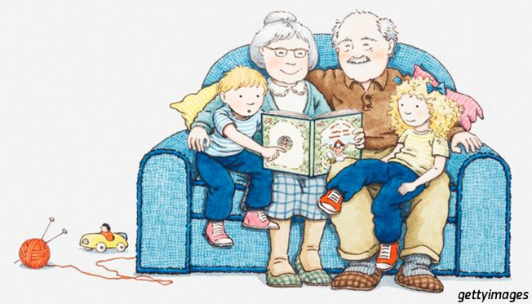 | 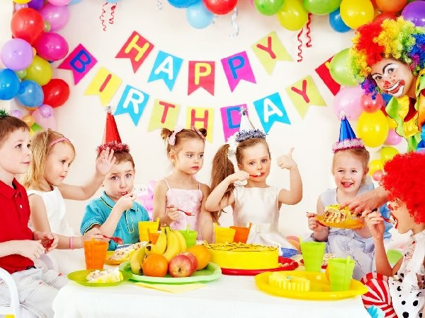
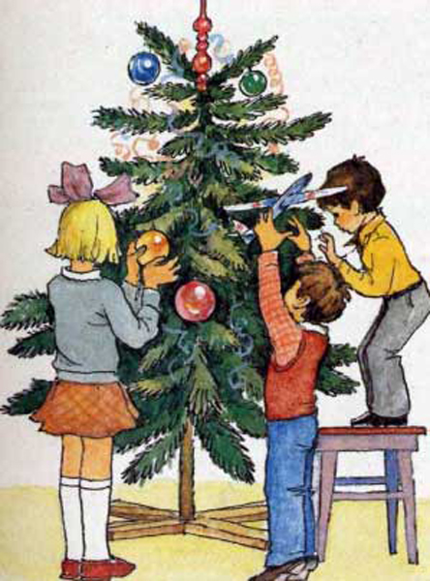 | 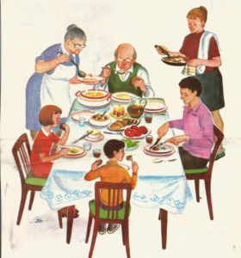
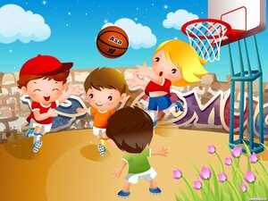 | 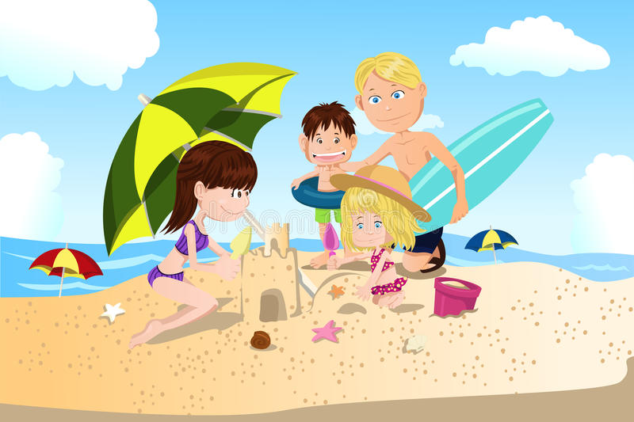
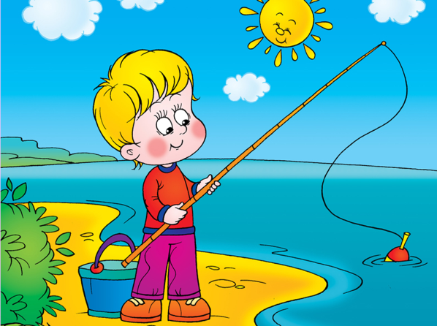 | 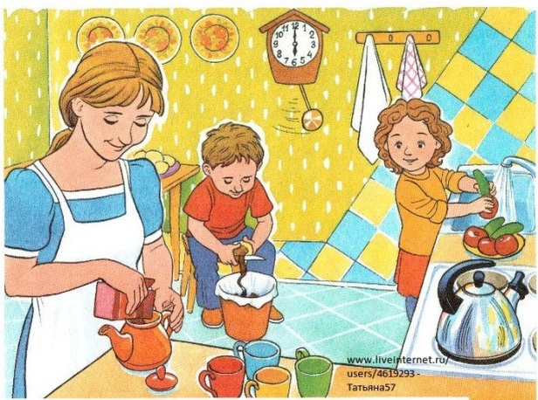
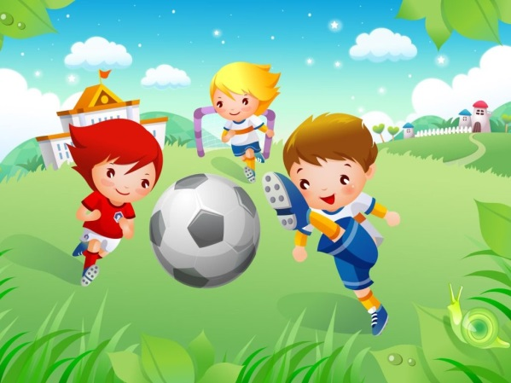 | 